EXPERIMENT 6
ROLL NO: 240701234
NAME: Karthik V

USER INTERFACE DESIGN

Aim
To simulate the lifecycle stages of UI design using the Rapid Application Development (RAD) model and develop a small interactive interface using Axure.

🛠 Tools Used
- Axure RP (for UI prototyping and interaction design)

📘 Introduction to RAD Model
Rapid Application Development (RAD) is a software development model that focuses on quick development and iteration through prototyping and user feedback. Unlike traditional models, RAD emphasizes working prototypes rather than extensive planning.
The RAD model consists of four main phases:
- Requirement Planning
- User Design
- Construction
- Cutover (Testing and Deployment)

🔄 RAD Lifecycle Applied to the Project
- Requirement Planning

The application developed is a Music Streaming Mobile Interface (Spotify).

Objective:

To create a simple and interactive UI that allows users to browse music, search songs, and play their favorite tracks.

Target Users:

• Music lovers
• Podcast listeners
• Casual and premium users

Key Features:
• Browse songs and albums
• Search music and artists
• View song/album details
• Play, pause, and skip tracks
• Create playlists and manage music

2. User Design (UI/UX Design)

In this phase, the user interface was designed based on the requirements. The design focuses on simplicity, usability, and smooth navigation for a better music listening experience.

Screens Designed:

🔹 Home Screen

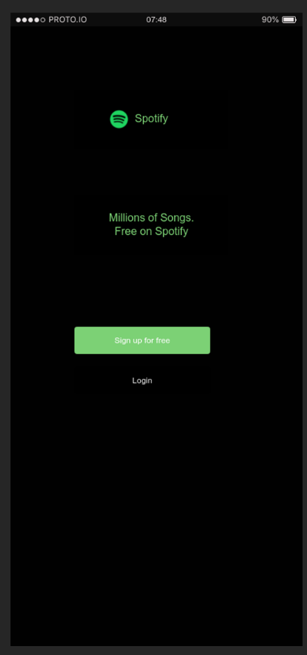
- Clean dark design of Spotify
- Easy options: Sign up or Login
- Highlights free music access

🔹 Music Search and Artists Screen

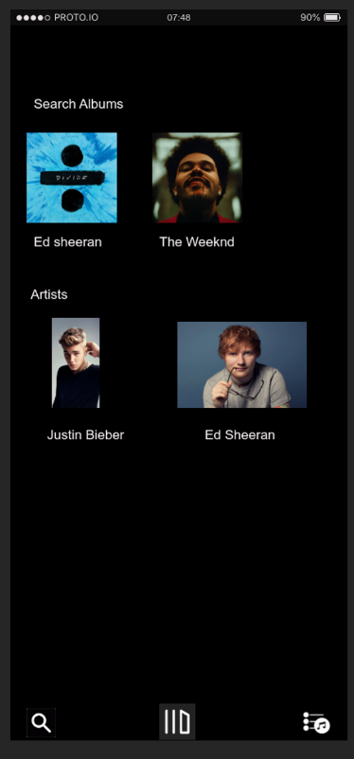
- Browse albums from Ed Sheeran and The Weeknd
- View popular artists like Justin Bieber
- Simple layout for quick music discovery

🔹 Now Playing Screen

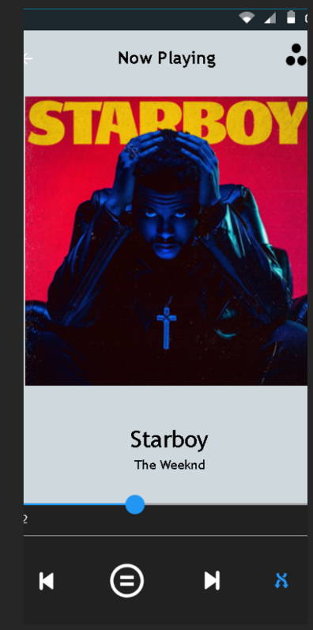
- Shows song “Starboy” by The Weeknd
- Easy controls for play, pause, and skip
- Clean interface focused on music playback

3. Construction (Prototype Development)
The prototype was developed using Axure RP.

Implementation Details:

• Each screen was created as a separate page
• Buttons were made interactive using OnClick events
• Navigation flow was implemented as follows:
o Home → Music Library
o Search → Song/Artist Results
o Select Song → Now Playing Screen
o Play Button → Music Playback
o Back → Home Screen

Key Features Implemented:
• Clickable buttons
• Page-to-page navigation
• Interactive music playback flow simulation
This phase demonstrates the RAD concept of rapid prototyping and functional UI development.

4. Cutover (Testing and Evaluation)
The prototype was tested using the preview feature in Axure.

Testing Results:

• All navigation flows worked correctly
• Buttons responded as expected
• User experience was smooth and intuitive

Limitations:

• No real music streaming backend
• Audio playback is simulated
• Limited search and filtering options

Future Improvements:
• Add real-time music streaming
• Include playlist creation and management
• Improve UI responsiveness
• Add user login and personalization

Result
A functional and interactive UI prototype of a music streaming application was successfully developed using the RAD model. The prototype demonstrates all stages of the RAD lifecycle

